**Collaboration Diagrams:**

A collaboration diagram, also called a communication diagram or interaction diagram, is an illustration of the relationships and interactions among software objects in the Unified Modeling Language (UML). The concept is more than a decade old although it has been refined as modeling paradigms have evolved.

A collaboration diagram resembles a flowchart that portrays the roles, functionality and behavior of individual objects as well as the overall operation of the system in real time. Objects are shown as rectangles with naming labels inside. These labels are preceded by colons and may be underlined. The relationships between the objects are shown as lines connecting the rectangles. The messages between objects are shown as arrows connecting the relevant rectangles along with labels that define the message sequencing.

Collaboration diagrams are best suited to the portrayal of simple interactions among relatively small numbers of objects. As the number of objects and messages grows, a collaboration diagram can become difficult to read. Several vendors offer software for creating and editing collaboration diagrams.

**Registration Collaboration diagram:**

User

Registration

BL:ClsRegistration

DL :SqlHelper

Data Base

1 : Register()

2 : Register()

3 : Execute NonQuery()

4 : Execute NonQuery()

5 : Response for Execute NonQuery()

6 : Get Response()

7 : Show Result()

**Login Collaboration diagram:**

User

Login

BL:ClsUser

DL:SqlHelper

Data Base

1 : Login()

2 : Check User()

3 : Execute Dataset ()

4 : Execute Dataset ()

5 : Response for Execute Dataset()

6 : Get Response()

7 : Show Result()

Importdataset collabration diagram

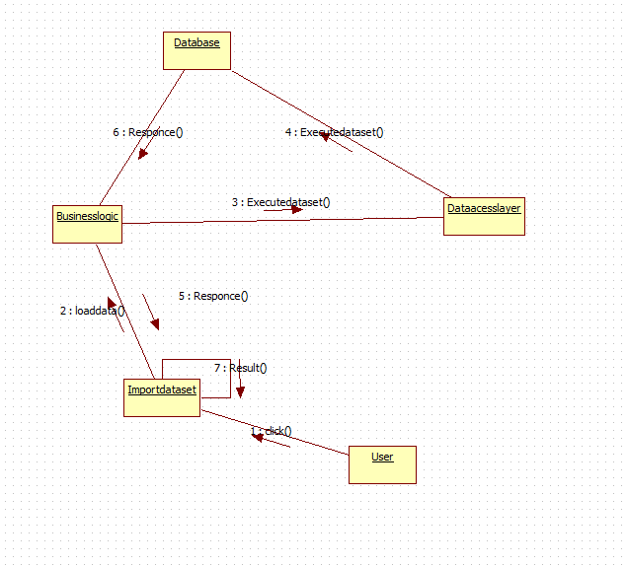

Data paritioning

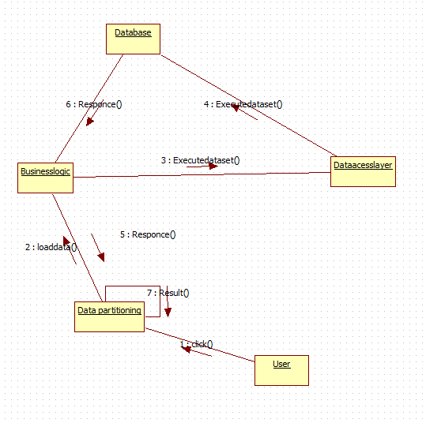

IPOL-HS

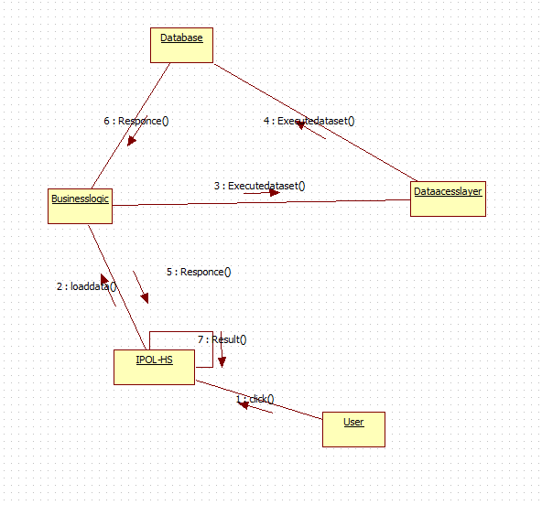

REGIONS

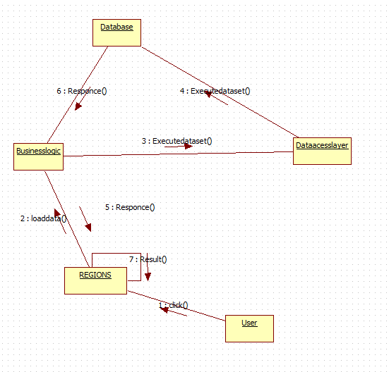

GROUPS

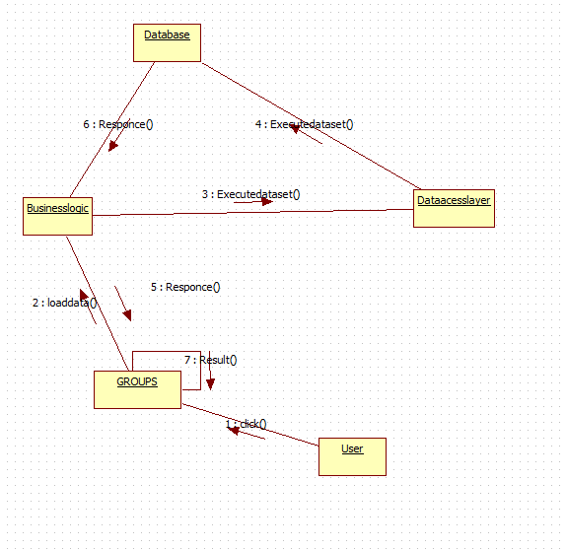

UPDATE DATA

